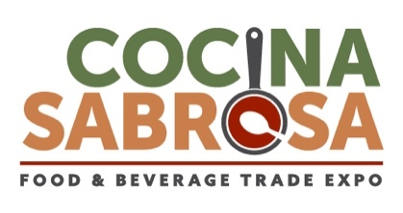

Booth #: _______
Company Name: _________________________________________________
Primary Contact: _________________________________________________
Email: _________________________________________________
Phone #: ___________________________

10 X 20 Booth Plot: Please draw all components of your booth and explicitly label the location of all cooking/warming devices.
Back of Booth

Front of Booth

List of Cooking/Warming Equipment
Please note: All electric cooking/warming devices must be UL safety rated. Devices without this rating and/or household rated devices are not allowed on the show floor.

Device(s) Circle One

- _______________________________________ UL Rated Yes / No
- _______________________________________ UL Rated Yes / No
- _______________________________________ UL Rated Yes / No
- _______________________________________ UL Rated Yes / No
- _______________________________________ UL Rated Yes / No
- _______________________________________ UL Rated Yes / No
- _______________________________________ UL Rated Yes / No
- _______________________________________ UL Rated Yes / No
- _______________________________________ UL Rated Yes / No
- _______________________________________ UL Rated Yes / No

