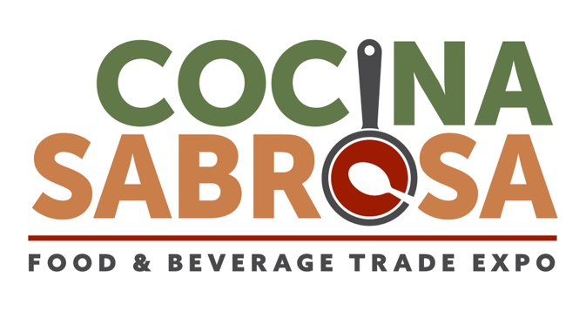
OFFICIAL GUIDE TO ONSITE COOKING

For Exhibitors COOKING SAMPLES FOR DISTRIBUTION onsite at a booth:
- Complete the Exhibitor Cooking/Sampling Form as soon as possible detailing your cooking/sampling plans if you have not already submitted.
- Review the Irving Convention Center Food Preparation During Exhibition or Demonstration Policy.
- Review the Savor… Las Colinas Sampling Policy for onsite distribution information.
- Connect with LVE, the General Services Contractor, if you need to ship items for cold storage prior to the event, and/or require onsite cold storage; subject to additional fees.
- A required handwashing station and fire extinguisher for your booth will be provided courtesy by Cocina Sabrosa show management for this year only.
PLEASE NOTE: This is required by the City of Irving Health Inspector. Failure to have an approved hand washing station, fire extinguisher and lid at your booth will prevent you from cooking and/or distributing samples at your booth and may result in fines and/or shutting down of your booth.
- Submit to the Cocina Sabrosa Director of Operations, Tim Berry, tim.berry@emeraldx.com the below required items no later than Friday, September 15, 2023.
  - Your approved City of Irving Temporary Food Event Permit.
  - A floorplan of your booth space outlining all furniture and cooking equipment placement for review by the fire marshal. Be sure to reference the Irving Convention Center Food Preparation During Exhibition or Demonstration Policy for specific requirements related to the size and placement of any cooking devices.

PLEASE NOTE: The dish washing sink inside of the exhibit hall concession stand will be available for shared exhibitor use.

APPENDICES

- Irving Convention Center Food Preparation During Exhibition or Demonstration Policy
- Savor… Las Colinas Sampling Policy
APPENDIX 1: Irving Convention Center Food Preparation During Exhibition or Demonstration Policy

Extracted from the Irving Convention Center at Las Colinas Exhibitor Kit.

Food shows present a special hazard for fire and life safety. The following regulations are provided in order to mitigate as many of these hazards as possible.
- Cooking and/or warming appliances must be isolated from the public. Place a minimum of 4’ back from the booth, or provided with a barrier between the cooking/warming device and the public.
- Individual cooking/warming devices shall not exceed 288 sq. in. surface area.
- A minimum of 2’ shall be kept between cooking devices.
- The surface which holds the cooking/warming device shall be of a non-combustible material.
- Combustible materials shall be kept a minimum of 2’ away from cooking/warming devices.
- A minimum 2A-10BC fire extinguisher and a lid or an approved automatic extinguishing system shall be required of any booth utilizing cooking or warming devices.
- Canned Heat is allowed for warming only and must not be refillable. An approved safety can must be provided where Canned Heat is used for disposal of the empty cans. (See Event Manager for details.)
- Candles are not allowed for cooking or warming.
- No flaming food preparation allowed in booths.
- No propane or butane allowed for cooking or warming.
- Deep fat fryers require splash guards on 3 sides. A class K fire extinguisher is required where deep fat fryers are used.

APPENDIX 2: Savor…Las Colinas Sampling Policy

Extracted from the Irving Convention Center at Las Colinas Exhibitor Kit.

- All food, beverages and concessions are operated and controlled exclusively by the Center’s catering Department, SAVOR… Las Colinas.
- As per company policy, it is not permitted to take any food and beverage off property.
- All food and beverage prices are subject to change.
- All catering services requested must be paid before the event date.
- An administrative fee and 8.25% sales tax will be added to any order. Administrative fees are taxable at 8.25%.
- Any and all exhibitors offering food or beverage sampling must have approval by SAVOR…Las Colinas. Upon approval, the exhibitor will then adhere to the following:
  - Items dispensed are limited to products Manufactured, Processed or Distributed by exhibiting companies and are related to the purpose of the show.
  - Sampling of products must be approved by SAVOR…Las Colinas. Upon approval, samples must be limited to the following: food items are limited to bite-size portions of 2x2 inches or 2-ounce portions; Non-alcoholic beverages are limited to a maximum of 4-ounce sample size.
  - Alcoholic Beverage Sampling:
    - Alcoholic beverages cannot be sold by exhibiting companies at any time.
    - Alcohol can be served as early at 10am only in conjunction with food service. Otherwise, alcohol cannot be served before noon.
    - All alcohol must be served in disposable cups; no cans or bottles allowed.
    - Distribution of alcoholic products must be ordered, monitored and overseen by a TABC attendant or bartender from SAVOR…Las Colinas.
    - Alcoholic Sample sizes include:
      - Beer: 4 oz
      - Wine/wine coolers/spirit coolers: 2 oz
      - Liquor/liqueurs: 0.5 oz
  - Food and/or beverage items used as traffic promoters (i.e., popcorn, coffee, bar services, etc.) must be purchased from SAVOR…Las Colinas.
  - Restrooms, concession stands, and/or facility kitchens may not be used as clean up areas.
  - Space utilized for storage, preparation, etc., of product must be approved in writing by SAVOR…Las Colinas and may be subject to additional fees.
  - Securing of all necessary licenses, permits, etc., is the responsibility of the Licensee/Exhibitor.
  - Costs associated with the disposal of trash, waste, etc., from exhibitor sampling area are the responsibility of the Licensee and/or Exhibitor.
  - Serving alcohol at booths must be done exclusively by a TABC-certified and SAVOR…Las Colinas attendant/bartender.
  - Exhibitors are not allowed to sell any food and beverage products for consumption at any time during the event.
  - Licensee is responsible for informing all parties of the Center’s food and beverage policies.
  - All alcohol or beverage services must be purchased through SAVOR…Las Colinas

